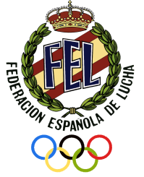

INTERNATIONAL TOURNAMENT
“JovenesPromesas”

GRECO-ROMAN / FREE STYLE / WOMEN’S WRESTLING – CADET/JUNIOR/U 23

Pilar de la Horadada (Alicante)/ SPAIN 7-8NOVEMBER2020

SPECIFIC INFORMATION
Details of the organizing Federation |  | Federación Española de Luchas Olímpicas y D.A.  C/ Amos de Escalante, 12, Bajo, 28017 Madrid - Spain  Tel. (0034) 91 4061666, Fax. (0034) 91 4061675  e-mail: esp@fila-wrestling.com ,fel@felucha.esweb mail : www.felucha.com
Details of competition venue |  | Pabellón de Deportes Duques de Palma de Pilar de la Horadada, Avda. de la Torre S/N (03190), Pilar de la Horadada (Alicante)
Competition system |  | Individual competition in 2mats underUWW rules
Medical service |  | Medical service during the event/stay is provided by the organiser. Medical examinations before departure to Spain is required and must be assured by the participating countries themselves.
Awards |  | Gold medal to the winner, Silver medal to the second place, 2 bronze medals to the third place. Awards for classification by teams.
Age group |  | Cadet/Junior/U23
Weight categories  (+2 Kg tolerance) | CADET | GR: 41/45 – 48 – 51 – 55 – 60 – 65 – 71 – 80 – 92 – 110 Kg.  LO: 41/45 – 48 – 51 – 55 – 60 – 65 – 71 – 80 – 92 – 110 Kg.  LF: 36//40 – 43 – 46 – 49 – 53 – 57 – 61 – 65 – 69 – 73 Kg.
Weight categories  (+2 Kg tolerance) | JUNIOR | GR: 55 – 60 - 63 – 67 – 72 – 77 – 82 - 87 – 97 – 130 Kg  LO: 57 – 61 – 65 – 70 – 74 – 79 - 86 – 92 - 97 – 125 Kg  LF: 50 – 53 – 55 – 57 – 59 - 62 – 65 – 68 - 72 - 76Kg
Weight categories  (+2 Kg tolerance) | U 23 | GR: 55 – 60 - 63 – 67 – 72 – 77 – 82 - 87 – 97 – 130 Kg  LO: 57 – 61 – 65 – 70 – 74 – 79 - 86 – 92 - 97 – 125 Kg  LF: 50 – 53 – 55 – 57 – 59 - 62 – 65 – 68 - 72 - 76Kg
Deadline for preliminary entries |  | September8 of 2020
Deadline for entries by name |  | October8 of 2020
COVID 19 |  | All participants must bring a negative PCR test (or antigens) carried out 72 hours before departure
Referee’s category |  | Cat. III, II and I
Reception of the teams |  | Airport Alicante / Rail station Alicante-Murcia
Details of hotel for the teams, referees, UWW Delegate |  | Hotel Pilar de la Horadada
Participation fee per day and person |  | COST PER PERSON AND PER DAY:  70 EUROS
Transport |  | All delegations must make transport arrangements from their country to Alicante airport at their own account. The same applies for their return home.  Each team must pay 25 Euros per person for the transport from Alicante airport and return.  The organizer will ensure local transportation (hotel, place of competition) during the competition.
TRAINING CAMP |  | After of thetournament, a Training Campwill be held between 9-11 November inFree Style, Greco-Roman and Women’s wrestling. The countries interested in participating are requested to mark the box inthe registration form.

INTERNATIONAL TOURNAMENT
“JovenesPromesas”

GRECO-ROMAN / FREE STYLE / WOMEN’S WRESTLING – CADET/JUNIOR/U 23

Pilar de la Horadada (Alicante) / SPAIN 7-8NOVEMBER2020

PROGRAM
Friday 6 November 2020 | Till 17H00 | Final entries for Cadets/U23
Friday 6 November 2020 | 19H00 | DRAW (All categories: Cadets) (All categories: U23)
Friday 6 November 2020 | 18H00-18H30 | Medical examination and Weigh-in (All categories: Cadets)
Friday 6 November 2020 | 18H30-19H00 | Medical examination and Weigh-in (All categories: U23)
Friday 6 November 2020 | 19H00 | Referee’s consultation
Friday 6 November 2020 | 20H00-22h30 | Dinner
Saturday 7 November 2020 | 07H00-07H30 | BREAKFAST
Saturday 7 November 2020 | 10H00-12H30 | Qualification rounds, ½ Final, RepechageCadets
Saturday 7 November 2020 | 12H30-14H00 | Bronze and Gold medal matches Cadets
Saturday 7 November 2020 | 14H00 | Awardsceremony Cadets
Saturday 7 November 2020 | 14H00-16H00 | LUCH
Saturday 7 November 2020 | 16H00-18H30 | Qualification rounds, ½ Final, RepechageU23
Saturday 7 November 2020 | 18H30-19H30 | Bronze and Gold medal matches U23
Saturday 7 November 2020 | 19H30 | Awardsceremony U23
Saturday 7 November 2020 | Till 17H00 | Final entries for Juniors
Saturday 7 November 2020 | 18H00 | DRAW (All categories: Juniors)
Saturday 7 November 2020 | 20H00-20H30 | Medical examination and Weigh-in (All categories: Juniors)
Saturday 7 November 2020 | 20H00-22h30 | DINNER
Sunday 8 November 2020 | 07H00-07H30 | BREAKFAST
Sunday 8 November 2020 | 10H00-12H30 | Qualification rounds, ½ Final, RepechageJuniors
Sunday 8 November 2020 | 12H30-14H00 | Bronze and Gold medal matches Juniors
Sunday 8 November 2020 | 13H00 | Food picnic distribution for teams
Sunday 8 November 2020 | 14H00 | Awardsceremony
Sunday 8 November 2020 | 15H00 | DEPARTURE TEAMS AND BUS FOR CAMPUS TRAINING
This program can be modified depending on the registrations received

INTERNATIONAL TOURNAMENT
“JovenesPromesas”

GRECO-ROMAN / FREE STYLE / WOMEN’S WRESTLING – CADET/JUNIOR/U 23
Pilar de la Horadada (Alicante)/ SPAIN 7-8NOVEMBER 2020

PRELIMINAR INSCRIPTION

National Federation .......................................

CADETS JUNIOR U 23

- Wrestlers ................ ................ …………

- Coaches ................ ................ …………

- Referees ................ ................ …………

- Officials ................ ................ …………

Total number of participants ........................

Date & Place ...................... ........................................
Signature - President

This form is to be returned to organisation not later than8 September 2020

We are interestedin participating in theCampusTraining from 9 to11November(YES or NO)

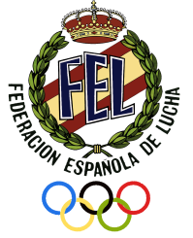
INTERNATIONAL TOURNAMENT
“JovenesPromesas”

GRECO-ROMAN / FREE STYLE / WOMEN’S WRESTLING – CADET/JUNIOR/U 23
Pilar de la Horadada (Alicante) / SPAIN 7-8NOVEMBER 2020
FINAL ENTRY JUNIOR

National Federation .......................

Team leader ...........................................................................................

Greco-Roman Men Free Style Woman Free Style
55 KG |  | 57 KG |  | 50 KG
60 KG |  | 61 KG |  | 53 KG
63 KG |  | 65 KG |  | 55 KG
67 KG |  | 70 KG |  | 57 KG
72 KG |  | 74 KG |  | 59 KG
77 KG |  | 79 KG |  | 62 KG
82 KG |  | 86 KG |  | 65 KG
87 KG |  | 92 KG |  | 68 KG
97 KG |  | 97 KG |  | 72 KG
130 KG |  | 125 KG |  | 76 KG

Coaches........................... ........................................ ....................................

Referees ...........................................................................................................

Other Officials .................................................................................................

Date, flight and hour or arrival ...................................................................

Date, flight and hour of departure ...................................................................

Date & Place ...................... ........................................
Signature – President

This form is to be returned to organisation not later than October 8 of 2020
INTERNATIONAL TOURNAMENT
“JovenesPromesas”

GRECO-ROMAN / FREE STYLE / WOMEN’S WRESTLING – CADET/JUNIOR/U 23
Pilar de la Horadada (Alicante)/ SPAIN 7-8NOVEMBER 2020
FINAL ENTRY U 23

National Federation .......................

Team leader ...........................................................................................

Greco-Roman Men Free Style Woman Free Style
55 KG |  | 57 KG |  | 50 KG
60 KG |  | 61 KG |  | 53 KG
63 KG |  | 65 KG |  | 55 KG
67 KG |  | 70 KG |  | 57 KG
72 KG |  | 74 KG |  | 59 KG
77 KG |  | 79 KG |  | 62 KG
82 KG |  | 86 KG |  | 65 KG
87 KG |  | 92 KG |  | 68 KG
97 KG |  | 97 KG |  | 72 KG
130 KG |  | 125 KG |  | 76 KG

Coaches........................... ........................................ ....................................

Referees ...........................................................................................................

Other Officials .................................................................................................

Date, flight and hour or arrival ...................................................................

Date, flight and hour of departure ...................................................................

Date & Place ...................... ........................................
Signature – President

This form is to be returned to organisation not later than October 8 of 2020

INTERNATIONAL TOURNAMENT
“JovenesPromesas”

GRECO-ROMAN / FREE STYLE / WOMEN’S WRESTLING – CADET/JUNIOR/U 23
Pilar de la Horadada (Alicante)/ SPAIN 7-8NOVEMBER 2020
FINAL ENTRY CADETS

National Federation .......................

Team leader ...........................................................................................

Greco-Roman Men Free Style Woman Free Style
41/45 KG |  | 41/45 KG |  | 36/40 KG
48 KG |  | 48 KG |  | 43 KG
51 KG |  | 51 KG |  | 46 KG
55 KG |  | 55 KG |  | 49 KG
60 KG |  | 60 KG |  | 53 KG
65 KG |  | 65 KG |  | 57 KG
71 KG |  | 71 KG |  | 61 KG
80 KG |  | 80 KG |  | 65 KG
92 KG |  | 92 KG |  | 69 KG
110 KG |  | 110 KG |  | 73 KG

Coaches........................... ........................................ ....................................

Referees ...........................................................................................................

Date, flight and hour or arrival ...................................................................

Date, flight and hour of departure ...................................................................

Date & Place ...................... ........................................
Signature - President
This form to be returned to organisation not later the October 8 of 2020

INTERNATIONAL TRAINING CAMP JUNIOR/CADET, GRECO-ROMAN / FREE STYLE AND WOMEN’S WRESTLING
9-11 November 2020, MURCIA(SPAIN)
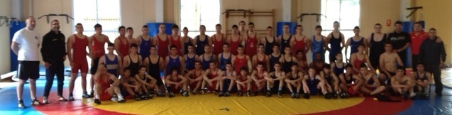

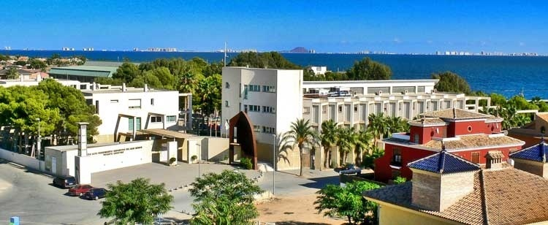

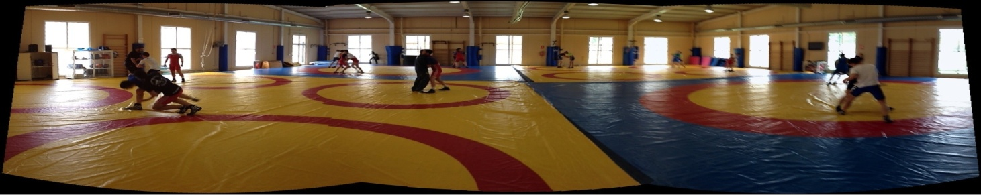

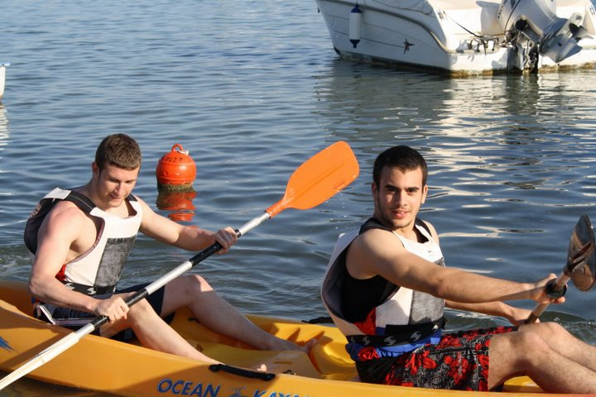
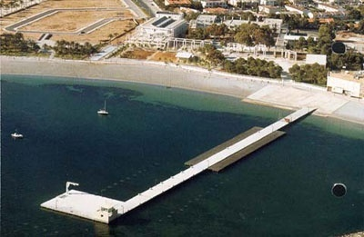

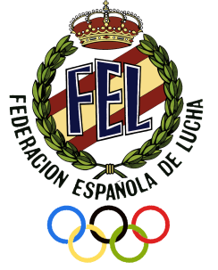
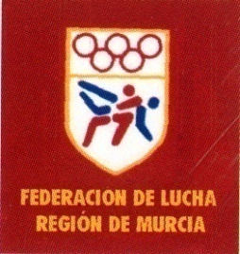

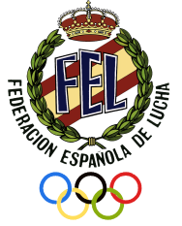
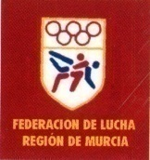

Dear President,
The Spanish Wrestling Federation has the pleasure to invite you to the: “International Training Camp” JUNIOR & CADET& U23 for Greco-Roman, Free Style and Women’s Wrestling in Spain from 9 to 11November 2020 with the next conditions:

INTERNATIONAL TRAINING CAMP

GRECO-ROMAN / FREE STYLE / WOMEN’s – JUNIOR/CADET

MURCIA / SPAIN 9-11 NOVEMBER 2020

SPECIFIC INFORMATION
Details of the organizing Federation | Federación Española de Luchas Olímpicas y D.A.  C/ Amos de Escalante, 12, Bajo  28017 Madrid - España  Tel. (0034) 91 4061666, Fax. (0034) 91 4061675  e-mail: ESP@fila-wrestling.com  e-mail: fel@felucha.com  http://www.felucha.com
Date of arrival | 8 November2020
Date of departure | 11 November 2020
Details of training venue | CAR Infanta Cristina (FILA CENTER)  Avda Mariano Ballester, 2,  Los narejos-Los Alcazares  30710 MURCIA,  Tel. 968575189, www.carmurcia.es
Age group | U 23/JUNIOR/CADETS
Weight categories | All categories
Deadline for entries by name | September 8 of 2020(preliminary) October 8 of 2020(nominative)
Costs | Each Delegation must pay 60 € per person and day. This includes:  - Meals from 8-11Nobember 2020  - Accommodation from 8-11Nobember 2020 in double and triple rooms.
Travel expenses | All delegations must make transport arrangements from their country to Alicante Airport at their own account. The same applies for their return home.  Transport from/to the airport from/to hotel will be borne by the organiser
Reception of the teams | Airport Alicante or Airport Murcia
Details of hotel for the teams | CAR Infanta Cristina  Avda Mariano Ballester, 2  Los narejos-Los Alcazares  30710 MURCIA,  Tel. 968575189, www.carmurcia.es  Hotel Costa Narejos  Calle Río Dobra, 2, 30710 Los Alcázares, Murcia  http://www.hotelcostanarejos.com/

